
USER MANUAL
Objective of the system:
Objective of developing this software application is to enable DTE. of Accounts to book all the Transfers / Remittances / Refunds received from various field offices, under correct Head of Accounts.
The following points may be kept in mind while entering details:
1) All remittances to Central Office from 01-04-2019 Should be entered and the same should be completed before 30 NOV 2019.
2) All remittances including fund received from Institutions, refund of unspent balances, miscellaneous receipts (i.e. Certificates Renewal Fees, IRG’s etc.) to be entered.
3) In case of remittances entered in IFMS by Field Offices, Document Number of the same to be entered.
4) Remittances by Cheque/Demand Draft/Direct Cash Deposit are also to be entered and counterfoil of the same to be upload.
5) All Details Should be verified after data entry and then click on forward button so that central office can view the remittances.
6) If there is any mistake made in data entry, you can rectify / delete the entry until it is forwarded to Central Office. Once Forwarded, no rectification is allowed.
7) For any inquiries, contact Cheque Section, KVIC Mumbai (Extension no. 124).

THE ONLINE SERVICES CAN BE AVAILED THROUGH WEBSITE https://kviconline.gov.in/safal/index.jsp

STEP 1 - LOG-IN USING YOUR USERNAME AND PASSWORD:

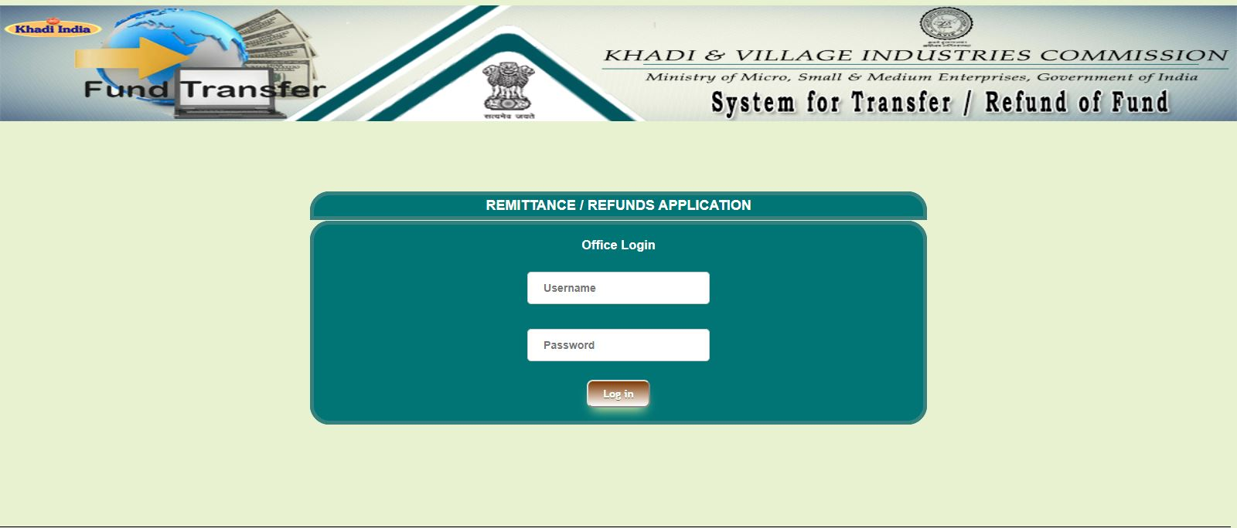
ENTER YOUR PASSWORD
ENTER YOUR USERNAME

STEP 2 - ONCE YOU LOG-IN SUCCESSEFULLY YOUR USER DETAILS WILL APPEAR ON THE PAGE

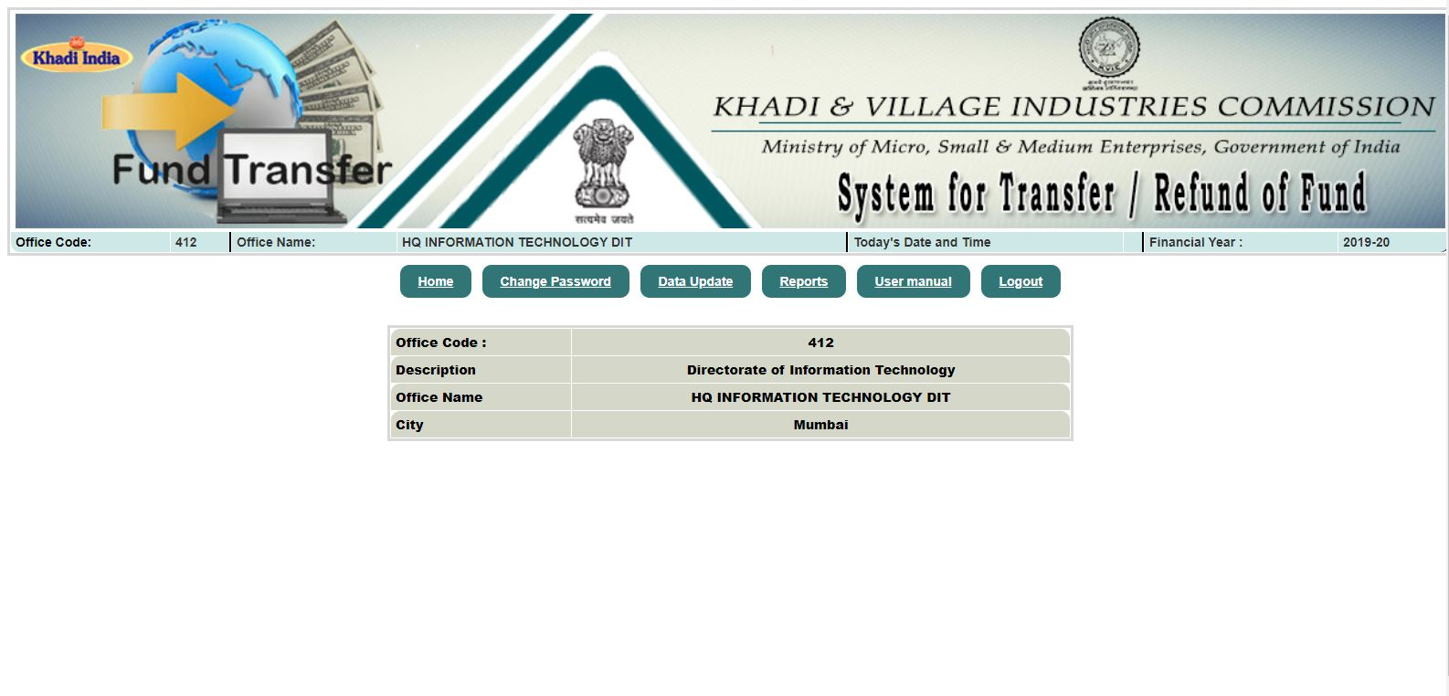

STEP 3 - CLICK ON “DATA UPDATE” TO VIEW ALL DETAILS OF REMITTANCE / REFUNDS SENT FROM RESPECTIVE OFFICE

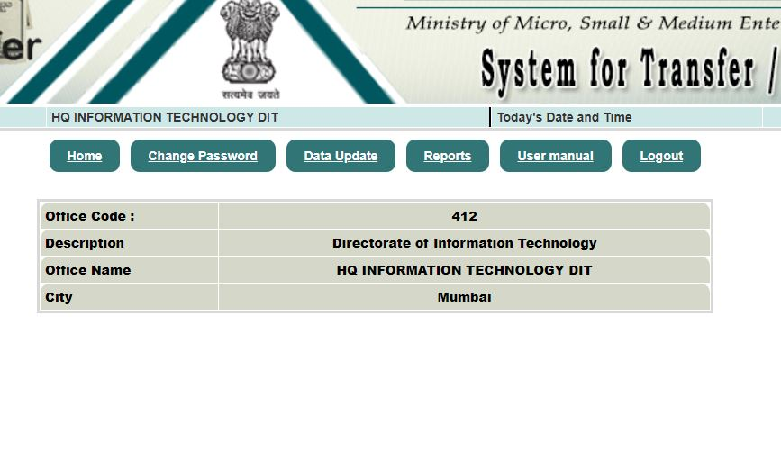
CLICK HERE TO ADD/UPDATE DATA

AFTER CLICKING ON “DATA UPDATE” ALL DETAILS OF REMITTANCE / REFUNDS SENT TO / FROM RESPECTIVE OFFICE WILL APPEAR ON PAGE

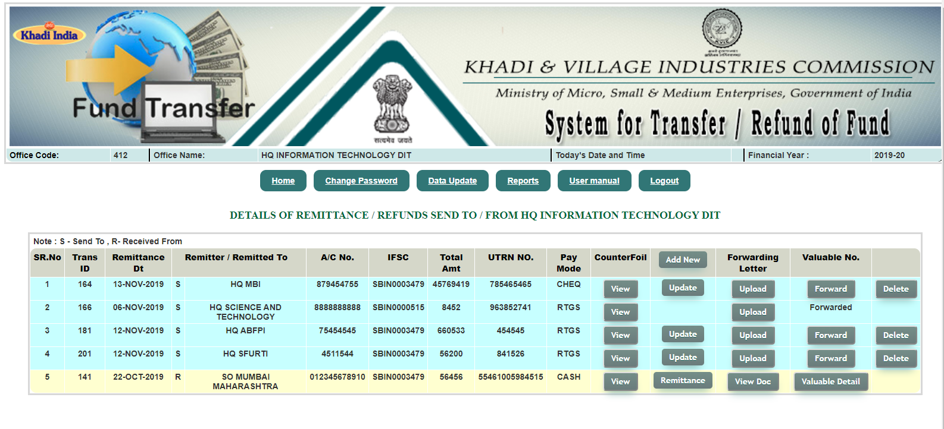

STEPS 4 - CLICK ON “ADD NEW” TO ENTER DETAILS OF REMITTANCE / REFUNDS SENT TO CENTRAL OFFICE

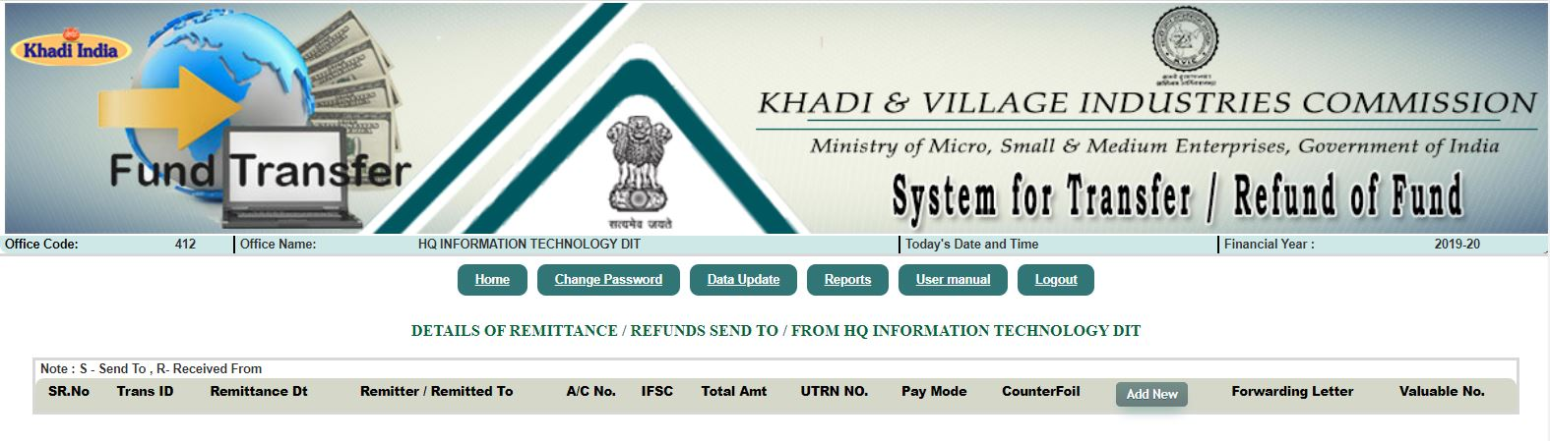

ADD NEW

STEP 5 - REMITTANCE / REFUNDS DATA ENTRY FORM

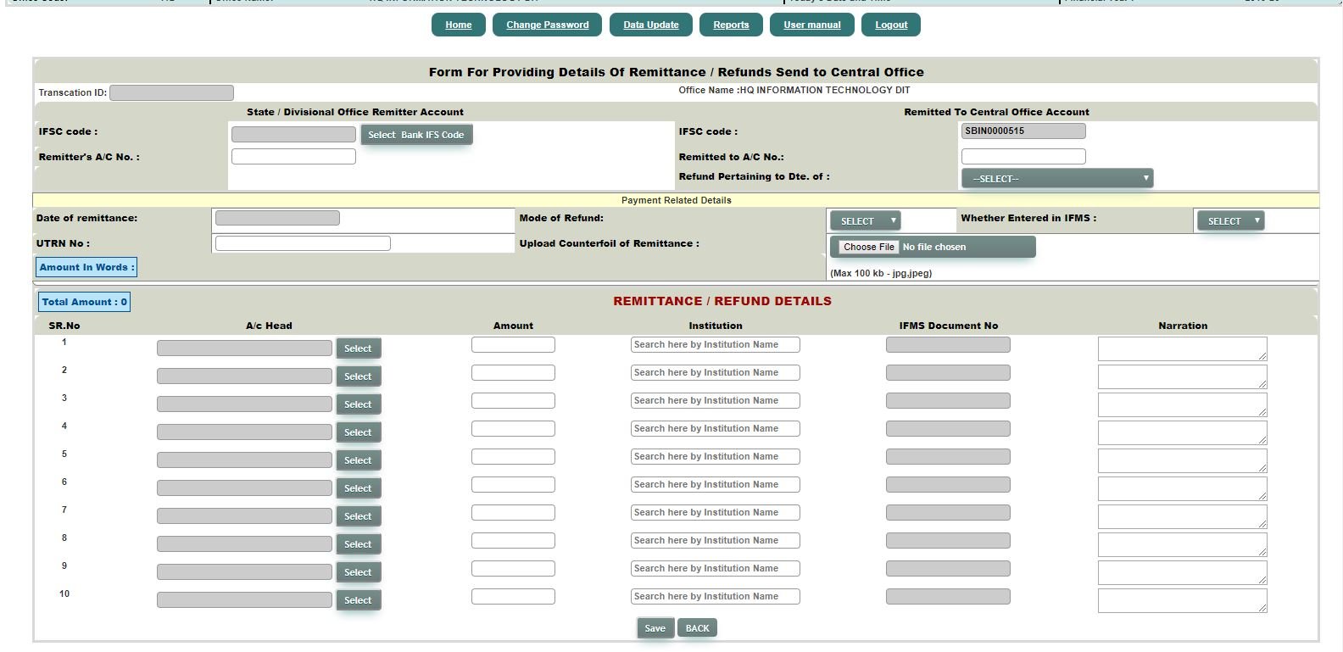

DETAILS PERTAIN TO BANK REMMITANCE

DETAILS PERTAINING TO SCHEME/HEADS UNDER WHICH THE REMMITANCE IS MADE

STEP 6 - BY CLICKING ON “VIEW” YOU CAN SEE ALL UPLOADED COUNTERFOILS

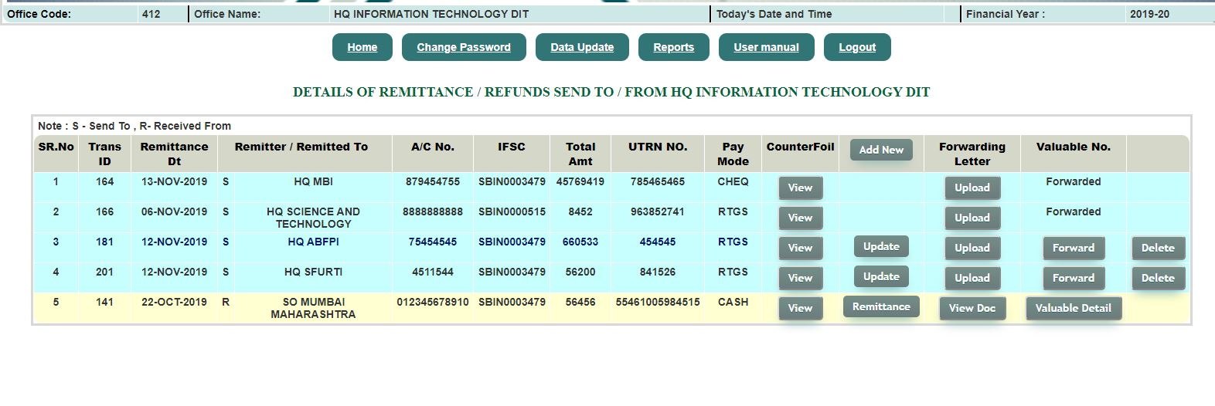
CLICK HERE TO VIEW ALL UPLOADED COUNTERFOILS OF RESPECTIVE REMMITANCE

STEP 7 - BY CLICKING ON “UPDATE” YOU CAN MODIFY YOUR ALREADY SAVED DATA


CLICK HERE TO UPDATE EXISTING APPLICATION

STEP 8 - BY CLICKING ON “UPLOAD” YOU CAN UPLOAD ADDITIONAL DOCUMENTS SUCH AS FORWARDING LETTERS


CLICK HERE TO UPLOAD ADDITIONAL DOCUMENTS

STEP 9 - SELECT AND UPLOAD DOCUMENTS

SELECT AND UPLOAD DOCUMENTS HERE

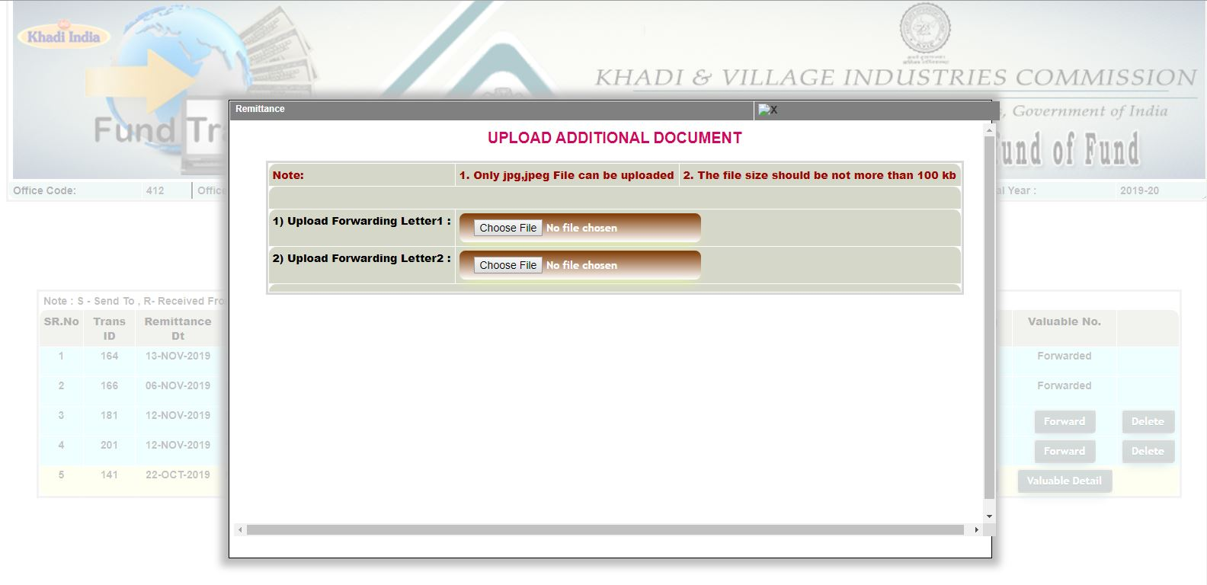

STEP 10 - BY CLICKING ON “DELETE” YOU CAN DELETE ANY WRONG ENTRY WHICH YOU HAVE NOT FORWARDED

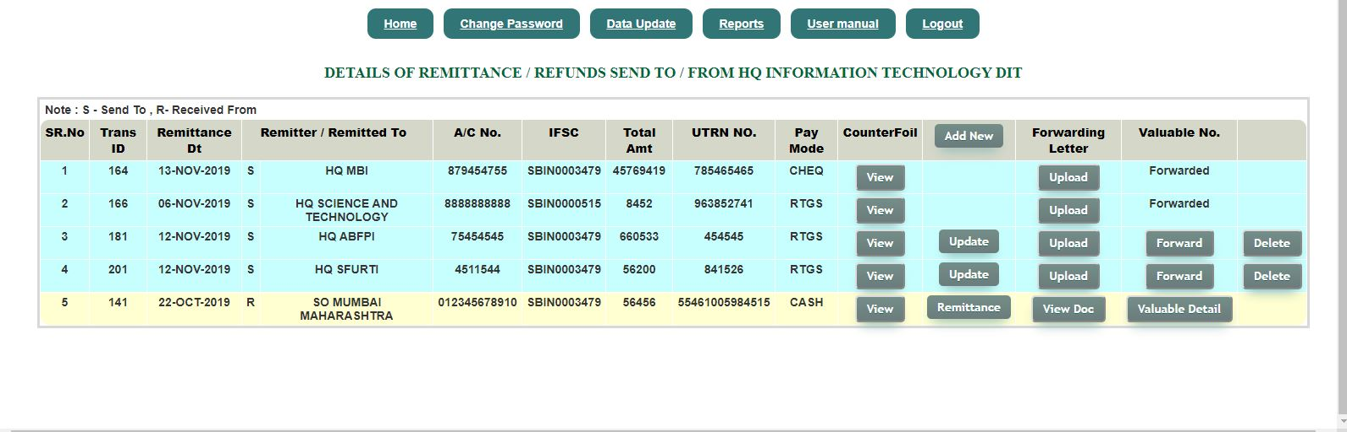

CLICK HERE TO DELETE REMMITANCE ENTRY
APPLICATION

STEP 11 - CLICK ON “FORWARD” BUTTON TO FORWARD DATA ENTERED BY FIELD OFFICE


CLICK HERE TO FORWARD REMMITANCE ENTRY

STEP 12 - BY CLICKING ON “YES” YOU CAN CONFIRM FINAL SUBMISSION OF REMMITANCE

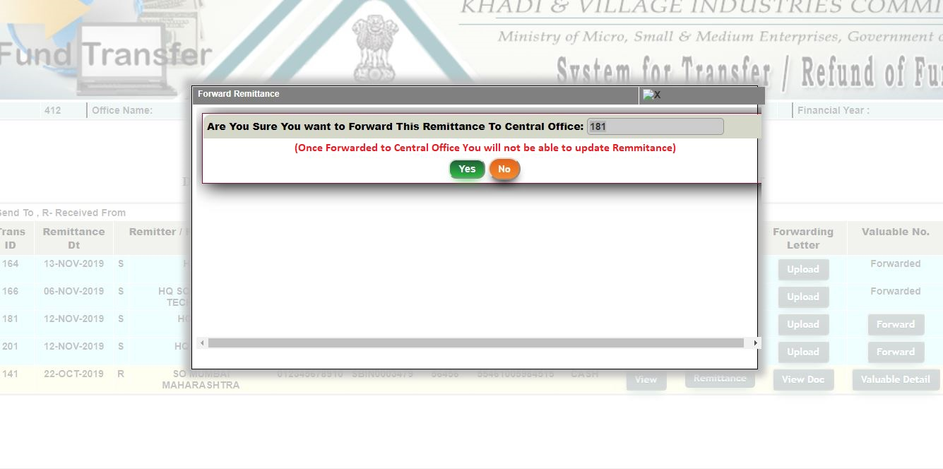

CLICK HERE TO CONFIRM SUBMISSION OF REMMITANCE

STEP 13 - CLICK ON “REMMITANCE” TO VIEW REMITTANCE / REFUND REPORT


CLICK HERE TO VIEW REPORT

STEP 14 - AFTER CLICKING ON “VIEW DOC” A POP_UP FORM WILL APPEAR WITH THE LIST OF ADDITIONAL DOCUMENTS UPLOADED


CLICK HERE TO VIEW LIST OF ADDITIONAL DOCUMENTS UPLOADED

STEP 15 - CLICK ON “VIEW DOC” TO VIEW UPLOADED DOCUMENTS

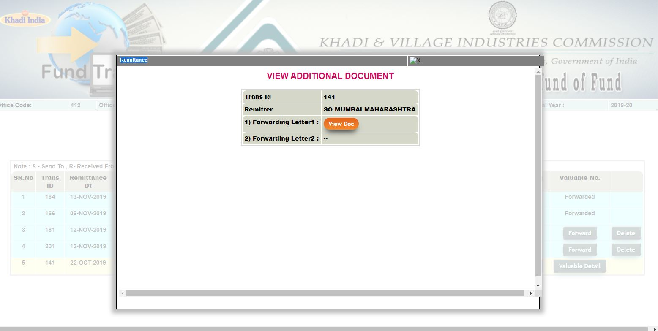
CLICK HERE TO VIEW UPLOADED DOCUMENTS

